

SOIL MOISTURE PREDICTION:

INSTITUTE: KLE TECHNOLOGICAL UNIVERSITY

TEAM DETAILS:

NAME email id

Rajeev MALLIGAWAD RAJEEVRM111@GMAIL.COM

Vipul S T vipulst.2002@gmail.com

sonia anvekar soniaanvekar3002@gmail.com

varsha N sali varshasali14@gmail.com

**PROBLEM STATEMENT:**



Soil moisture is an important variable that affects the growth of crops and the overall health of agricultural lands. Predicting Soil Moisture beforehand can be very useful in various fields, from agriculture to natural disaster management and climate modeling. Predicting soil Moisture can help us in controlling droughts, they can help farmers in planning their irrigation schedules, seed planting, harvest timing, etc. The task is to predict soil moisture levels at a specific location based on the previous 8 months of soil moisture data along with temperature, and humidity values at the location.

**Task:**

We are required to build a machine-learning model that can predict soil moisture levels for March 2023, based on the previous 8 months of data. The model should take in daily soil moisture measurements from July 2022 to March 10, 2023, and output predicted soil moisture measurements for March 2023.

**Data:**

The dataset contains daily soil moisture measurements from July 2022 to March 10, 2023, at our Space Data Science Lab, IIT Dharwad. Each data point consists of a date, corresponding soil moisture measurement, and other attribute values.

**INTRODUCTION:**

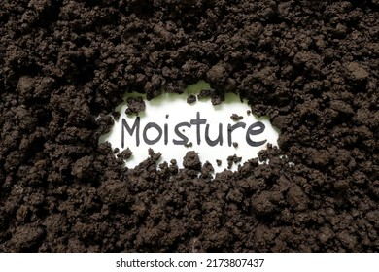

The livelihood of most people in India is reliant upon agriculture. Soils in India.  
Not as productive in terms of micronutrients. Over the last few years, it has been observed that there is a correlation between soil health and the aforementioned topic. By maintaining the appropriate methods and techniques, the agriculture field can experience an improvement in both sustainability and current crop yield levels. Soil’s fruitfulness. The survival and growth of the inhabitants of Earth depend primarily  on water. Moisture levels in the soil serve a crucial function in keeping plants healthy and are also vital for maintaining adequate water supply. The systems of soil-plant-atmosphere that operate in a self-sustaining cycle.

**Importance of soil moisture:**

It's crucial to have knowledge of the quantity of soil water or moisture due to the following reasons:

1.Soil moisture acts as a chemical solution and brings essential nourishment to aid the  development of plants.

1. The amount of water available determines the crop yield.  
   3. Soil water functions as a nutrient component independently.  
   4. The movement of water in the soil determines the temperature of the soil.  
   5. Soil forming processes and weathering are dependent on the presence of soil water.  
   6. The metabolic functions of microorganisms rely on soil moisture.  
   7. Soil water aids in the chemical and biological processes occurring within the soil.  
   8. The growth of plants relies mostly on soil as its essential component.  
   9. Photosynthesis requires water as a vital component.

**Objective:**

1. To predict the soil moisture requirement, based on the previous 8 months of data by using the Machine Learning Algorithms.
2. To study the machine learning approach for detection of the patterns by using both supervised learning algorithms. i.e., Multivariate Regression.

**Description:**

This piece of work aims to enhance the method of forecasting soil moisture utilizing a  technique based on machine learning. The dataset contains daily soil moisture measurements from July 2022 to March 10, 2023, at our Space Data Science Lab, IIT Dharwad. Each data point consists of a date, corresponding soil moisture measurement, and other attribute values. According to research, machine learning algorithms are capable of predicting the requirements for soil moisture in agriculture.  
The levels of temperature and atmospheric humidity have a significant impact on how  accurately the future years can be predicted. The Different machine learning algorithms have varying degrees of accuracy. Following the  data transformation, the degree of precision increased. converted for time series into a supervised learning format while retaining the same algorithm.

Avg is 1.  
Through the use of time_series supervised learning data, an improvement in  trend prediction accuracy has been noted.

To enhance future research, it is recommended that the predictive system be expanded  to integrate precipitation predictions. Secured by this.  
To enhance water conservation, irrigation is optimized by utilizing the forecasted rainfall depths to their fullest potential.  
Creating models that are specific to each crop through the use of a comprehensive data-set gathered from areas with comparable soil properties will lead to...  
strengthen the implementation of soil moisture models that derive from collected data in  irrigation scheduling applications. A key objective for creating these models is to generate accurate Soil Moisture Content assessments. Information is here.  
Knowing the rough conditions of the fields is extremely beneficial for farmers and water  researchers, as it provides guidance on how to proceed.  
Make better and more effective decisions concerning farming techniques like using  fertilizers and watering crops.

**DATA ANALYSIS AND DESCRIPTION:**

User1_data: Dataset

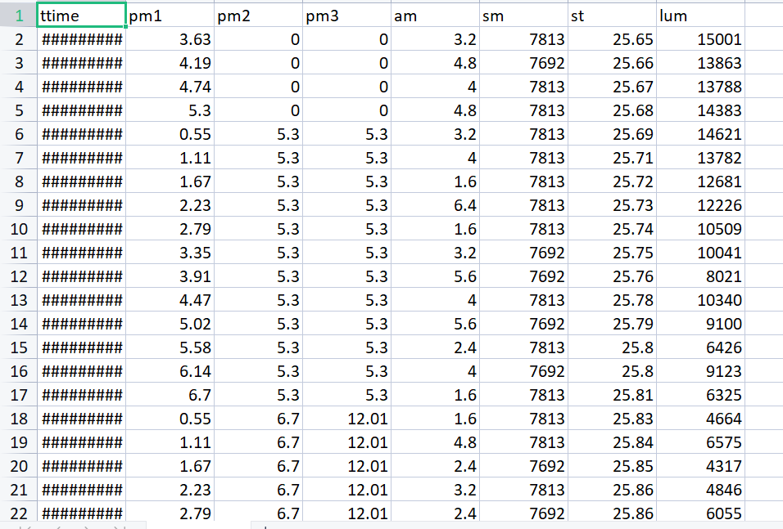

Description

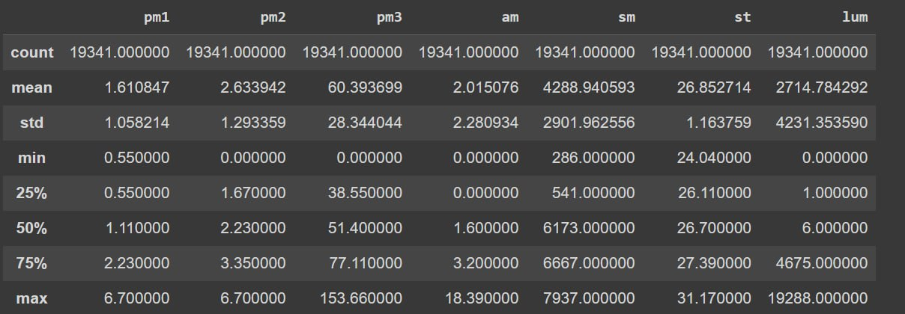

Graphical :

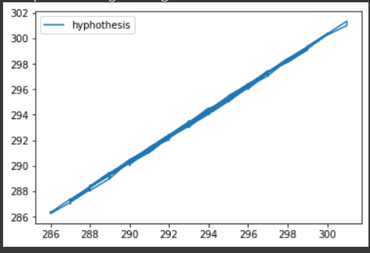

User2_data: Dataset

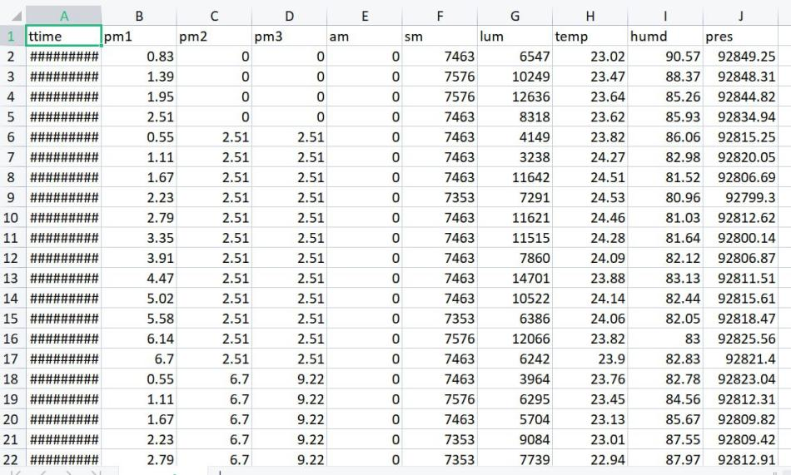

Description

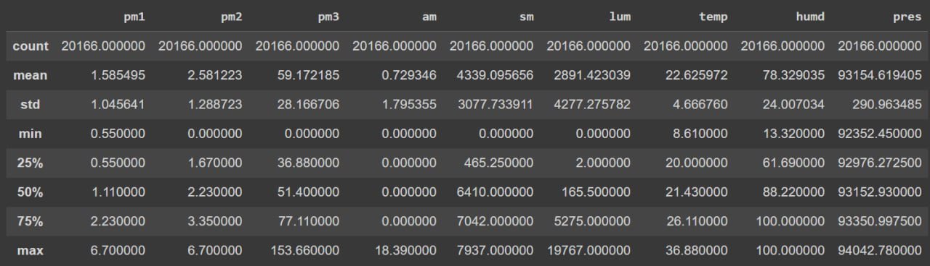

Graph:

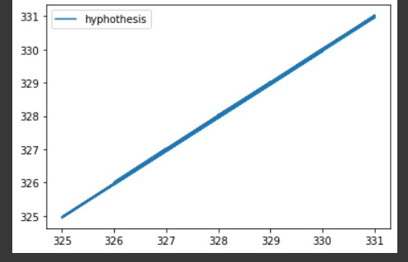

**RESULTS AND DISCUSSION:**

**User1_data:**

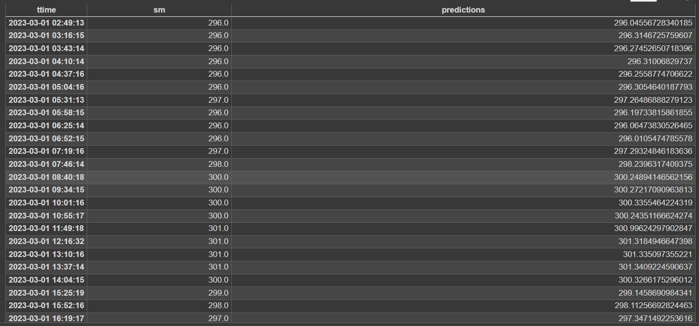

Mean Absolute Error : 0.2699708872885638

Mean Square Error: 0.08477646242950597

Root Mean Square Error: 0.292263978591914

**User2_data:**

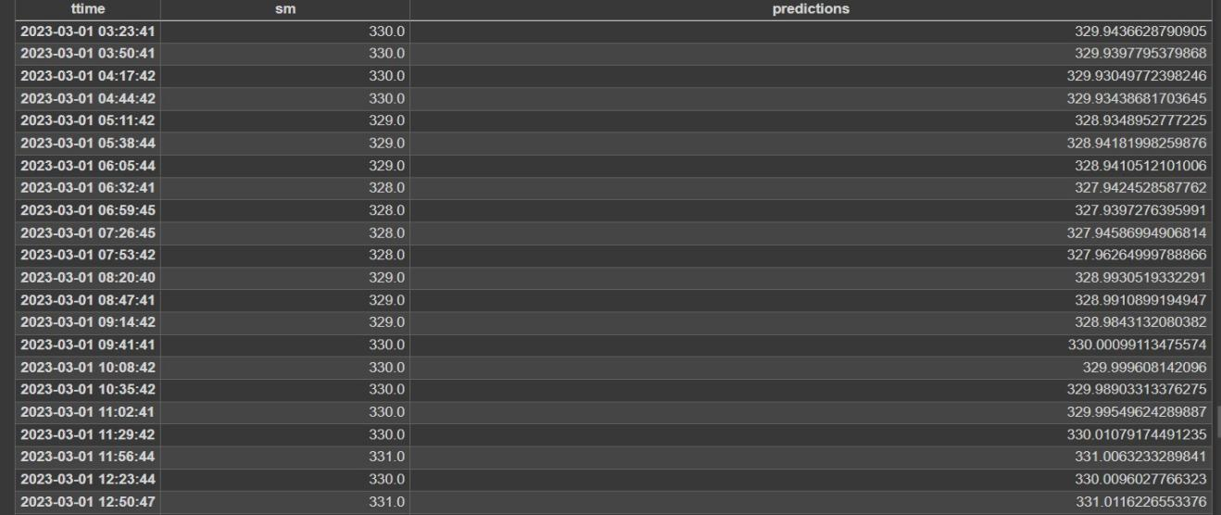

Mean Absolute Error : 0.03205461216207105

Mean Square Error: 0.0013733256346747352

Root Mean Square Error: 0.037058408420690914

**REFERENCES:**

[1]H.P. Das, P.A. Kore, S.B. Gaonkar, and I.J. Verma, "Water use pattern of rice and its relationship with ration over coastal Andhra Pradesh", MAUSAM, 54, 3(3 July 2003), 717-722. [2]Bhatt P. (2017), “Water requirement, growth and yield of yellow mustard(Brassica juncea L.) through nonweighing lysimeters associated with shallow, medium and deep water table conditions", G.B. Pant University of Agriculture and Technology, Pantnagar, India. [3]Clercq. D. M., Vats, Biel, "Agriculture 4.0: The future of Farming Technology", World Government Summit, 2018. [4]Vyas, S.P., Garg, B.K., Kathju, S., & Lahiri, A.N. (1995), "Influence of nitrogen on Indian Mustard grown under different levels of stored soil moisture", Journal of Arid Environments, 29(2), 173-184. [5]Cai. Y., Zheng. W., Zhang. X., Zhangzhong. L., & Xue. X.(2019), "Research on soil moisture prediction model based on deep learning", Research Article. [6]Natsagdorj., E., Renchin., T., Kappas., M., Tseveen., B., Dari., C., Tsend. O., &, Duger., U.O.(2017), "An integrated methodology for soil moisture analysis using multispectral data in Mongolia",Journal of Geo-spatial Information Science, Volume 20, 2017 – Issue 1. [7]Abdrabbo., A., A., M., (2010), "Water consumption of eggplant under different microclimates", Agriculture Research Center, Egypt, May 2010, with 674 reads. [8]Ahmad., S., Kalra. A., &, Stephen, H., (2009), "Estimating Soil Moisture Using Remote Sensing Data: A Machine Learning Approach", Article, Advances in Water Resources 33(1): 69-80 [9]Adeyemi., O, Grove., I., Peets., S., Domun., Y., & Norton., T., (2018), "Dynamic Neural Network Modelling of Soil Moisture Content for Predictive Irrigation Scheduling", MDPI Article, Belgium. [10]Prakash., S., Sharma., A., &, Sahu., S. S., (2019), "Soil Moisture Prediction Using Machine Learning", IEEE Article. [11]Begum., F., A., & Paul., N., K., (1993), "Influence of Soil Moisture on Growth, Water Use and Yield of Mustard", Department of Botany, University of Rajshahi 6205, Bangladesh, J. Agronomy & Crop Science 170, 136-141, 1993 Paul Parey Scientific Publishers, Berlin and Hamburg ISSN 0931-2550. [12]Tiwari., K., Goyal., R., &, Sarkar., A., (2017), "Impact of Wheat and Mustard Crop Water Requirements on Water Resources Management of Development Corridor", Article in Plant Archives, October 2017. [13]Khavse., R, Singh., R, Manikandan., N., Chandrawanshi., S.K., &, Chaudhary., J.L., (2014), "Crop water requirement and irrigation water requirement of mustard crop at selected locations of Chhattisgarh State, India", Department of Agrometeorology, Indira Gandhi Krishi Vishwa Vidyalaya, Krishak Nagar, Raipur 492012, India, Eco. Env. & Cons. 20 (Suppl.): 2014 ; pp.(S209-S211), ISSN 0971-765. [14]Swathi Gorthi, (2011), "Prediction Models for Estimation of Soil Moisture Content", All Graduates Theses and Dissertations, Utah State University, DigitalCommons@USU, in 2011 ASME/IEEE International Conference on Mechatronic and Embedded Systems and Applications(MESA2011). [15]T. J. Jackson, "Soil water modeling and remote sensing," IEEE Transactions on Geo-sciences and Remote Sensing, vol. 24, pp. 37–46, 1986.